ENGG 1410: Mini Project #2 F23

“Introduction to C Programming”:

GPS System

Completed by Mark de Lima and Kavin Manamperi

November 10, 2023

# Problem Statement

The problem this code aimed to solve was creating a programme that allows the user to know their position in the world relative to another user.

Assumptions and Constraints

Assuming the user can enter their position and time, the program will be able to take in that information and put it into a “database” with data from other users. This data can then be used to find the distance between each user.

Some constraints for this program could be the user not inputting the incorrect data type, the incorrect number of data types or not formatting the text file properly. If the input text file is not setup properly, the program will be unable to run as the data cannot be read in.

Problem Solving Process

Dealing with project problem was tackled by breaking up larger tasks into smaller, more manageable problems. The project was broken up into a few main components to make the problem-solving process as smooth as possible. For example, breaking up the code into the different functions. Going through the program line by line is a great way to make sure we avoid any possible mistakes.

# Flowchart

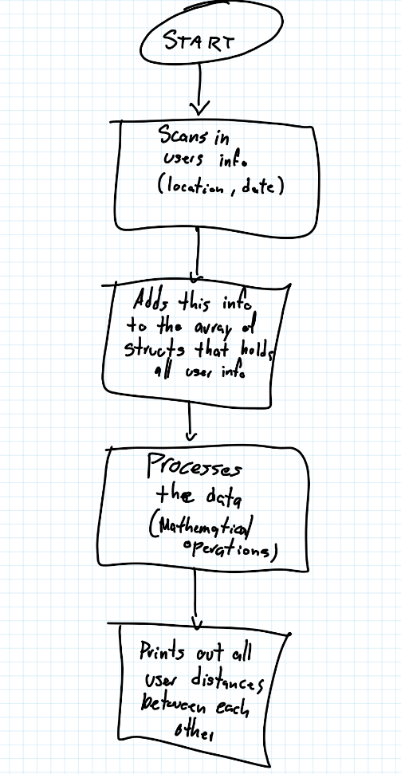

# System Overview & Justification

The program works by intaking a text file and with users' information (position, time) and sends that data into an array of structs. This data is then processed and compared to other users from around the world with different latitude and longitude and altitude. To compare the user's data to each other, you must process the data given through some mathematical operations. After this, the data can finally be returned to the user, citing how far they are from other users who have entered their data into the program.